|  |  |
| --- | --- |
| **Name:- Aryan Dilipbhai Langhanoja** | **Roll Number:- 92200133030** |
| **Subject Name and Code:-** Foundation Skills On Sensor Interfacing (01CT1103) | **Date of Experiment:- 13-11-2023** |

|  |  |
| --- | --- |
| Task:- |  |

* Interface Bluetooth module with arduino uno development board and control the appliances using bluetooth.

|  |  |
| --- | --- |
| Components: |  |

* Arduino Uno R3
* Blutooth Module HC05
* Jumper Wires (Male To Male)
* Laptop Or PC

|  |  |
| --- | --- |
| About the Project:- |  |

* In this Project, We are going to interface Bluetooth module with Arduino. In that we connect VCC to 5V and ground to GND. TX pin to RX and RX pin to TX. We will connect LED to signal pin and key pin to any GPIO pin.

|  |  |  |
| --- | --- | --- |
| Output:- (you circuit implementation |  |  |

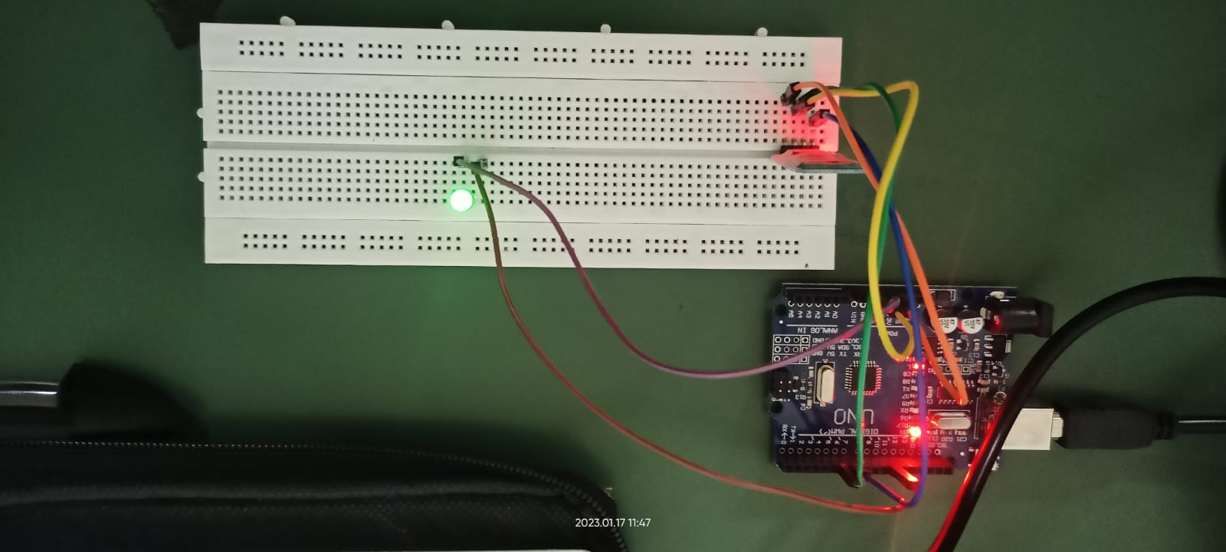

|  |  |
| --- | --- |
| Code:- |  |

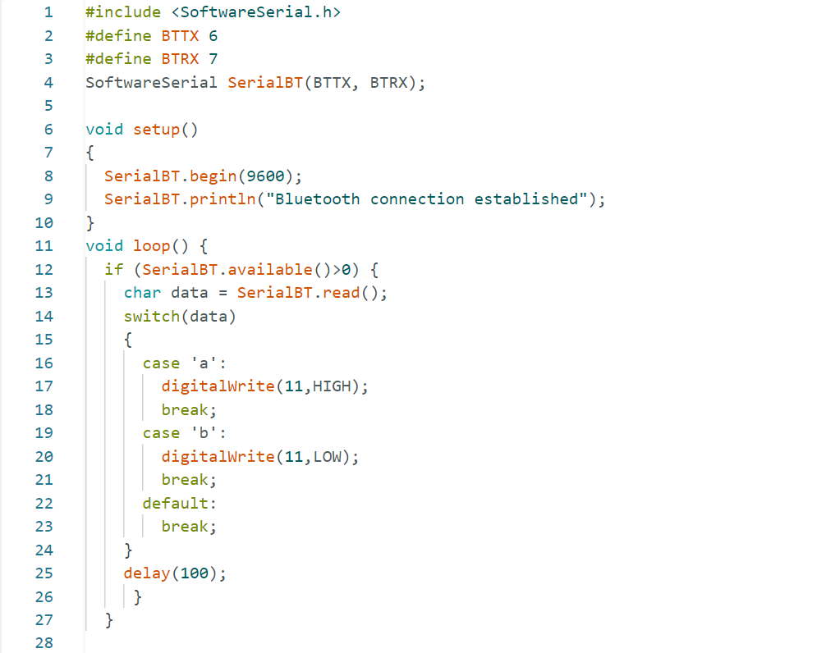

|  |  |
| --- | --- |
| Conclusion:- |  |

* In This Experiment, We Learnt That How To Interface Bluetooth Module with The Arduino.